This game is called Zemljo krasti – stealing the land. We need: chalk and a stick or a small branch (hard enough so you can throw it). We begin with drawing a big circle and dividing it into as many equal parts as there are players. Each one of the players can name his part of the land after countries or continents.

ZEMLJO KRASTI – STEALING THE LAND
The players are standing outside the circle in front of their land. One of the kids takes the stick, puts it in the middle of the circle and releases the stick. The players must be watchful, because if the stick lands on someones land, they have to quickly step on it and shout stop. Meanwhile the others try to run as far as possible and after they hear the word stop, they must stop.
Afterward the person with the stick tries to hit the person closest to him. If he succedes, he can take a part of his land otherwise the person who has been targeted but not hit can take his.
Person can steal the land by standing or crouching on his land and then drawing a line with chalk on the other person’s land, as big as possible. The game is finished when there is no land left.
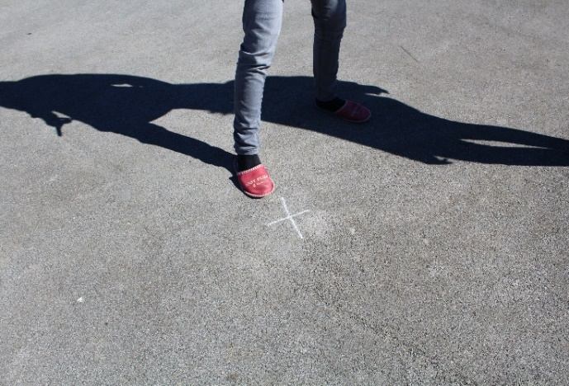
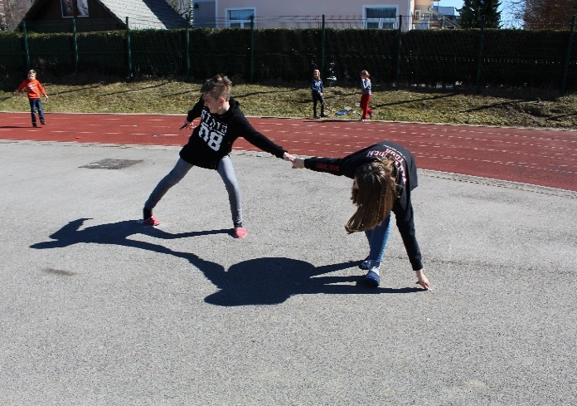
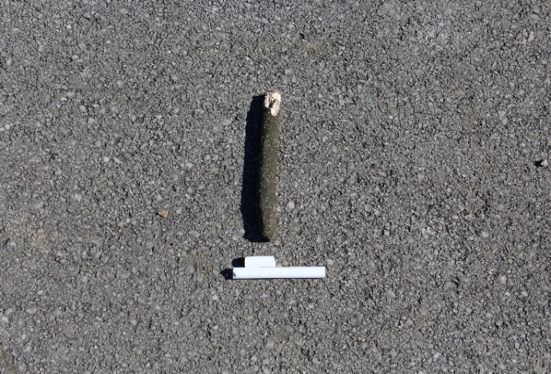
CENTER OF THE CIRCLE
DRAWING A BIG CIRCLE
CHALK AND A STICK
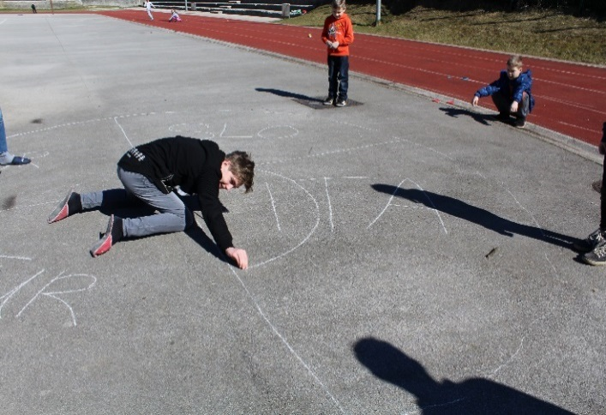
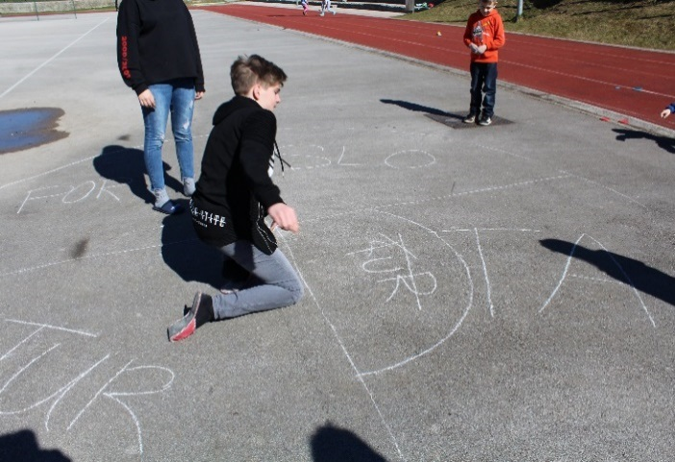
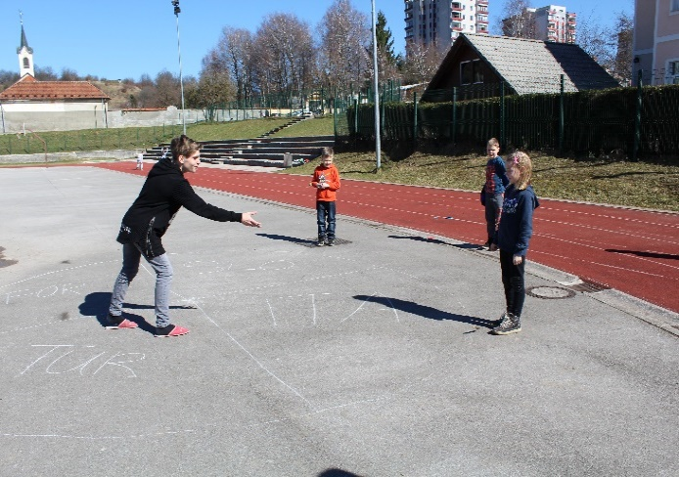
DRAWING A LINE
THE END OF THE ROUND
TARGETING THE PLAYER

