KAMENČKE TALAT
Otroci se posedejo v ravno vrsto.
En je prodajalec, drugi pa uganjevalec. Roke sklenejo predse v naročje in za toliko razprejo dlan, da lahko prodajalec kamenčka seže mednje. Prodajalec gre med njihovimi rokami in govor: »Prodam, prodam kar sam rad imam.« Medtem enemu spusti kamenček v roke. Uganjevalec, ki stoji malo stran mora na koncu razdeljevanja ugotoviti komu je prodajalec spustil kamenček v roke. Če je uganil pravega (tistega, ki ima kamenček v rokah) ta takoj steče okrog vrste uganjevalec pa ga lovi. Če pride nazaj na svoje mesto predenj ga uganjevalec ulovi, se igra ponovi. Če ga uganjevalec ujame, se ta zamenja z uganjevalcem. Če uganjevalec sploh ne ugotovi pravilne osebe se prav tako igra ponovi.
POTREBUJEŠ:
- kamenček,
- 5-20 ljudi.
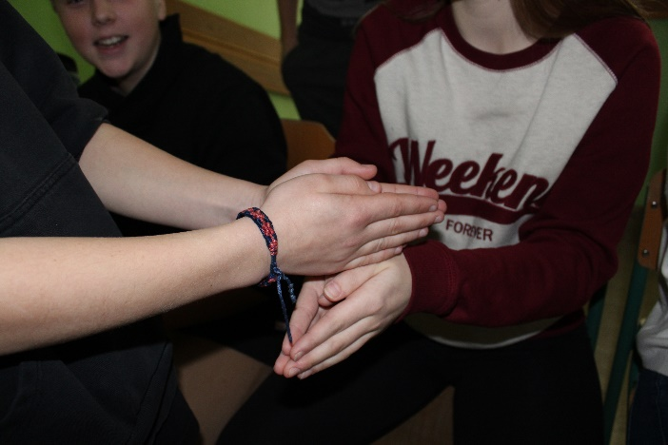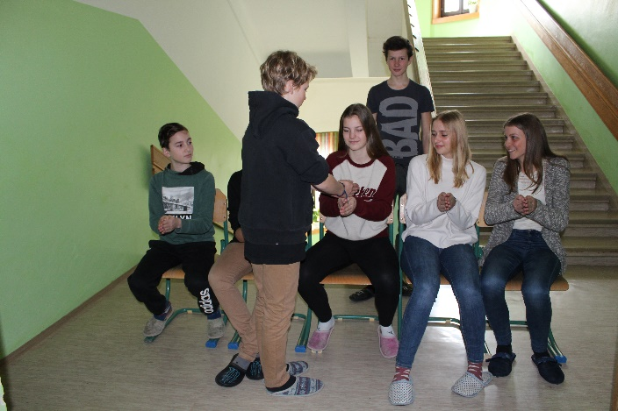

SHARING STONES
Children sit down in line.
One person is a seller, another one is a selector. The childdren put their hands ahead and open them a little, so that there is enough space for a little stone. In the meanwhile the seller is walking and talking: »I sell, I sell the things I like the most.« Than he gives a stone into someone’s hand. When the seller comes to the end of the line, the selector was stands a few meter away, must guess, who has the stone in his hands. If he guesses the right person, this one must immediately run around the line, and the seller is hunting him. If he comes back to his place before is caught, the game repeats, if not, he must replace the selector.
If the person, who was definite haven’t stone in his hands the game also repeats.

YOU NEED
-a little stone
-5-20 people
