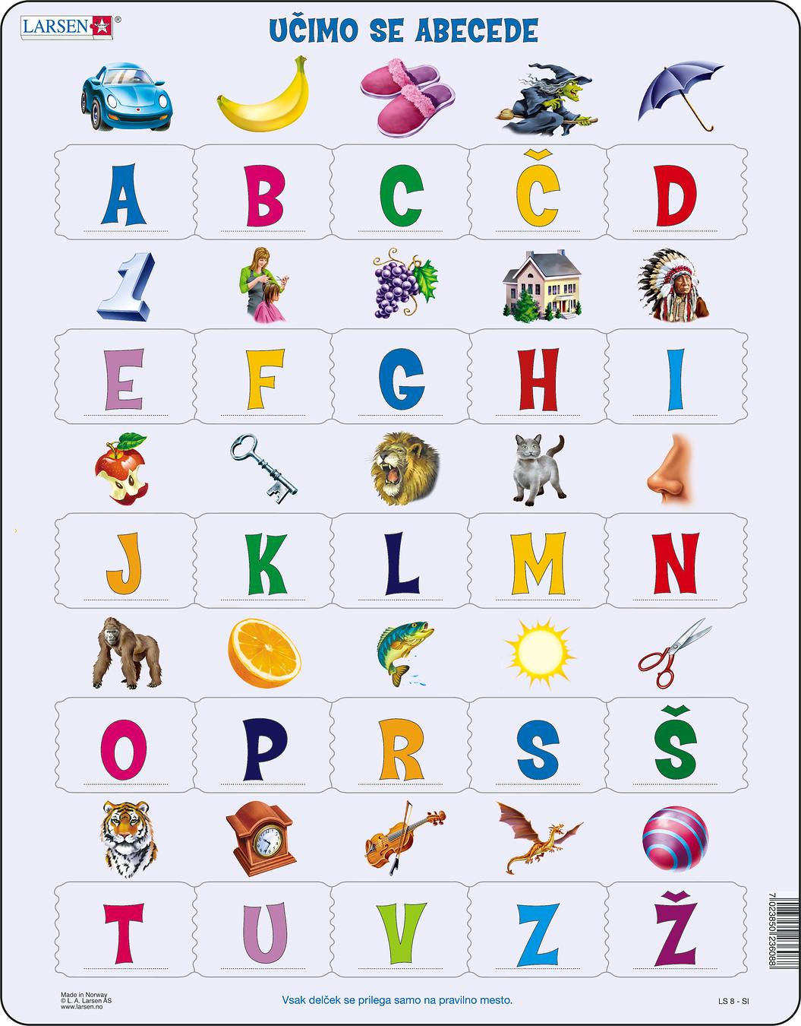

- AVTO (car) L- LEV (lione)
- BANANA (banana) M- MAČKA (cat)
- COPATI (slippers) N- NOS (nose)
Č- ČAROVNICA (witch) O- OPICA (monkey)
- DEŽNIK (umbrella) P- POMARANČA (oranges)
- ENA (one) R- RIBA (fish)
- FRIZER (hairdresser) S- SONCE (sun)
- GROZDJE (grapes) Š- ŠKARJE (scissors)
- HIŠA (house) T- TUIGER (tiger)
- INDIJANEC (indian) U- URA (clock)
- JABOLKO (apple) V- VIOLINA (violin)
- KLJUČ (key) Z- ZMAJ (dragon)
Ž- ŽOGA (ball)

Slovenian alphabet has 25 Latin letters. Latin is the handwriting of the old Romans. Many handwritings of today derive from it. The Slovene alphabet is also called the Slovene gajica, as it originates from a font that Ljudevit Gaj prepared for Croats in the 19th century. There are 25 characters in the Slovenian alphabet, 5 of which are for vowels (a, e, I, o and u) and 20 consonants (b, c, č, d, f, g, h, j, k, l, m, n, p, r, s, š, t, v, z and ž).
What is the alphabet?
The alphabet is a regular sequence of letters in some typeface, especially in Latin. The name is derived from the first four letters in the Latin alphabet - a + be + ce + de.
Črka | IPA | Črka | IPA
A, a | /a/ | M, m | /m/
B, b | /b/ | N, n | /n/
C, c | /ts/ | O, o | /ɔ/, /o/
Č, č | /tʃ/ | P, p | /p/
D, d | /d/ | R, r | /r/
E, e | /ɛ/, /e/, /ə/ | S, s | /s/
F, f | /f/ | Š, š | /ʃ/
G, g | /g/ | T, t | /t/
H, h | /x/ | U, u | /u/
I, i | /i/ | V, v, | /v/, /w/
J, j | /j/ | Z, z | /z/
K, k | /k/ | Ž, ž | /ʒ/
L, l | /l/, /w/
The special feature of the Slovenian alphabet is the foresters. These letters have a roof above them.
C + ˇ = Č
S + ˇ = Š
Z + ˇ = Ž
The Slovene alphabet does not have the letters y, w, q and x.

For Slovenians, the oldest text in Slovene is of inestimable value. It is not written in today's lettering of the bagpipes, but in the medieval Carolingian minuscule, which is also a type of Latin.
These are the Bruges memorials, two prayer forms of public confession and sermon on sin and penance, which are found in the Latin Code and are kept in Munich today. The Bruges monuments dating from around 1000 are the oldest Slavic text in Latin.
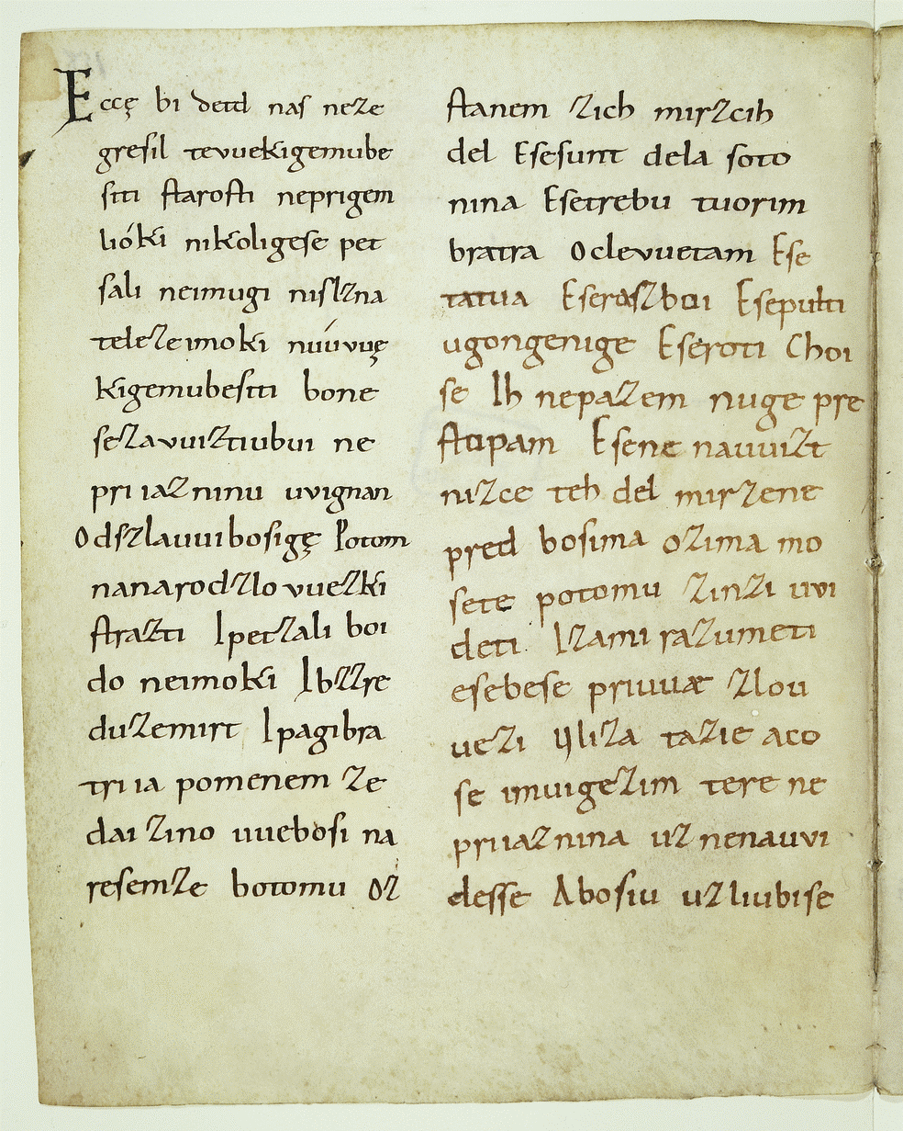

The photo shows the beginning of the most important part of the Bruges monuments. In today's Slovenian, it would read: If our grandfather had not sinned ...

